Let’s Get Ready to go back to Primary School!

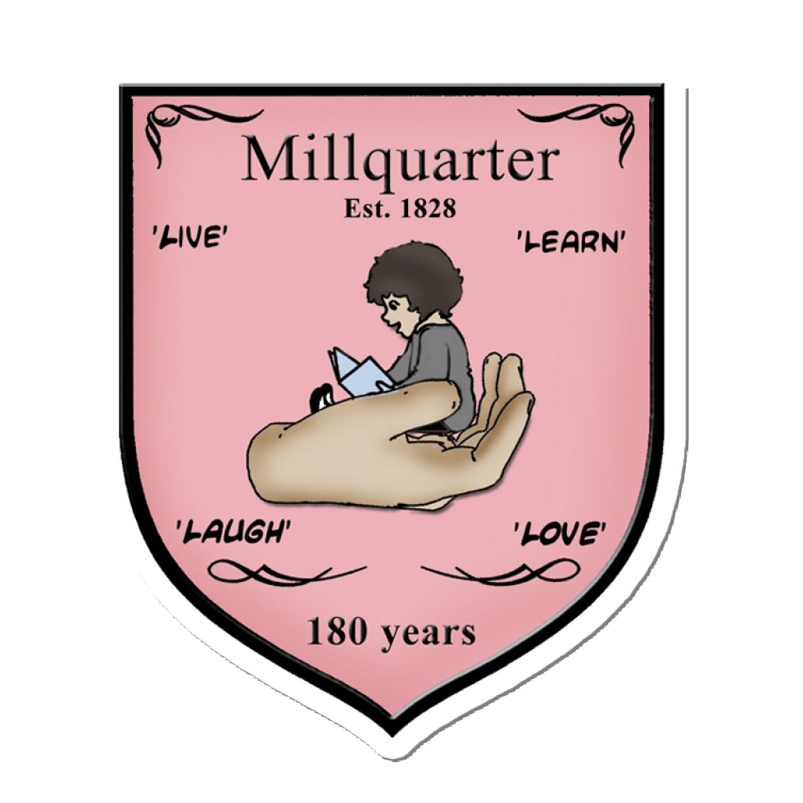

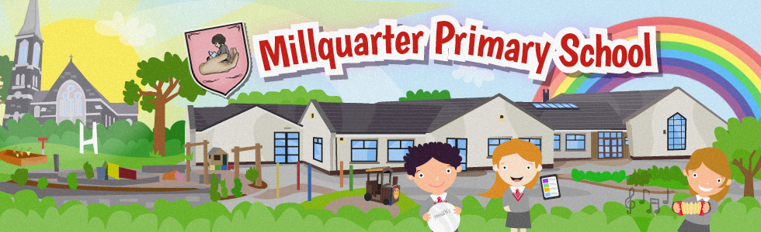

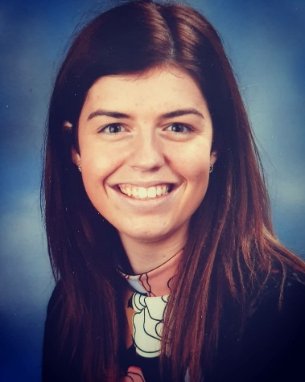My name is __________________ and I am ______ years old. When I return to school on Tuesday 25th August, I will be in Primary 6. This year, my teacher will be Miss Downey.

To help you with your feelings about returning to school and to prepare you for the return, I made this booklet to help.

It has a story to help explain about going back to school and some of the changes there will be. It should also help you to understand how you are feeling about going back to school. I can’t wait to see you all!

Any worries you might have can be talked about and, you can come up with ideas to help make these worries smaller.

**What about me?**

☺ It might help me to understand my feelings.

☺ It might help me to prepare for going back to school.

☺ It will explain some of the new rules and how school might be different to how it was before.

☺ I will work through this booklet with my parents or another adult and try to have fun.



I will be going back to school… soon



Write down the names of people who can help you e.g. mum, dad, teacher, friend.

**How do I feel about going back to school?**

**How do I feel about going back to school?**

It is really important to think and talk about going back to school. Over the next days, take time to do this. It’s good to share these thoughts and feelings with family or friends.

There are lots of different words that can be used to describe the same feeling. Complete the colour wheel with different words to label each feeling. Then colour in each section with the colour that you think best represents each feeling.

**How Do I Feel Today?**

Look at the pictures below. Which one describes how you are feeling today about going back to school?

Talk to family or friends about why you feel that way.

It is ok to have lots of different feelings about going back to school. This can be confusing. Think about and complete the ‘feeling bubbles’ below – remember, it’s about going back to school.

**I am worried that…**

**I am happy because…**

[](https://www.bing.com/images/search?view=detailV2&ccid=mQADUq%2bE&id=44E8ED6091848C69C0D9C0B101586877602FD932&thid=OIP.mQADUq-E1gmb73ym2pXY3wHaHa&mediaurl=http://clipartix.com/wp-content/uploads/2016/05/Thinking-clip-art.jpeg&exph=831&expw=830&q=Thinking+Emoji+Clip+Art&simid=607998327854861914&ck=28B4ECFB582862F673FCE064DB872A8A&selectedIndex=3&adlt=strict&FORM=IRPRST)[](https://www.bing.com/images/search?view=detailV2&ccid=tG43rNsm&id=BFDB76B02C0A91A853896ACDCBDCF8367288A7C1&thid=OIP.tG43rNsmu1uCh2-9E5pUKAHaJl&mediaurl=http://clipartmag.com/images/thinking-face-clipart-4.jpg&exph=1650&expw=1275&q=Thinking+Emoji+Clip+Art&simid=608032713374371332&ck=81A82EBBD5A1AB9DB82634A90209B455&selectedIndex=2&adlt=strict&FORM=IRPRST)

**I am scared that…**

**I am excited to…**

**I am angry because…**

**I am sad because…**

Feeling worried, sad, angry, or scared? Think of some activities which make these feelings smaller. For example, singing, baking, watching TV or playing on the iPad.

Come up with a list of activities which make your feelings feel smaller and draw a picture of them.

**Try some of these calming activities:**

**Counting**



Count your fingers slowly, tapping each one out as you go. Try to focus only on counting. Keep going for as long as you feel you need to.

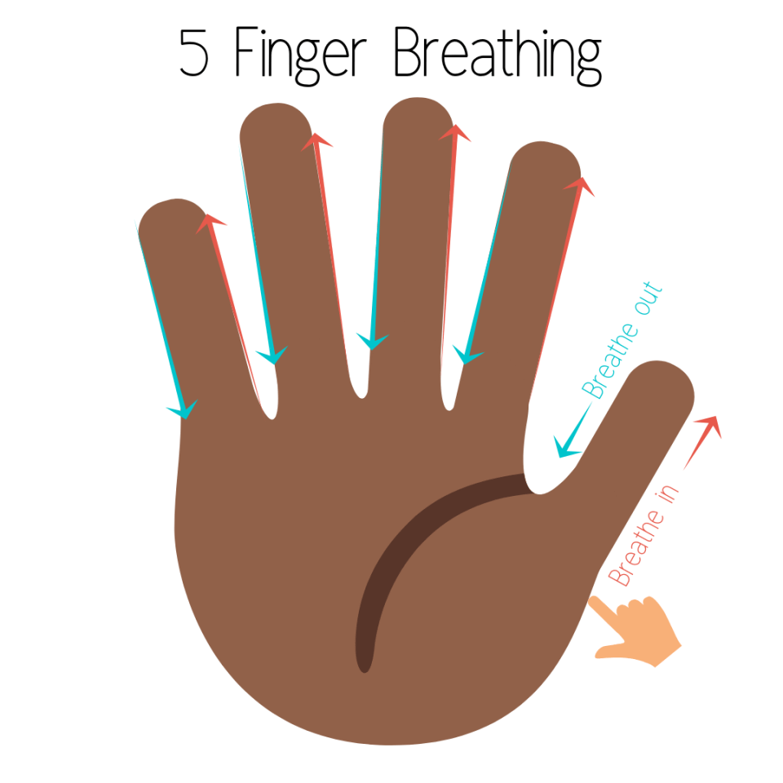**Finger Breathing**

Breathe in deeply as you trace up your thumb. Pause and hold your breath at the top of your thumb then breathe out slowly as you move down your thumb. Keep going until you have used all your fingers/thumb.

**My favourite place**

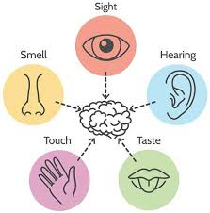

Think of your favourite place or a special memory. Imagine you are right there in this very moment. Name something that you can hear, smell, taste, what you could touch and what you could see.



**I spy**

Try to find 3 things in the room that:

• are blue

• are red

• begin with the letter S

• are soft

• are shiny

All the emotions we feel in our body are normal. It is important to recognise these feeling in our own bodies so that each person can manage their own feelings. Make time to do some fun and enjoyable, or calming activities regularly during the day – try not to wait until you are feeling very worried, scared, sad or angry to try them.

**School might be different:**

When you return to school, there might be new rules to help keep us, our family and others safe and well. These rules might include:

**Keeping your distance:**

We will have to keep our distance from other people. This means staying a certain distance apart which can be called ‘social distancing’. The distance we may need to stay apart from others might change from place to place. Teachers and parents will let everyone know what the distance is.

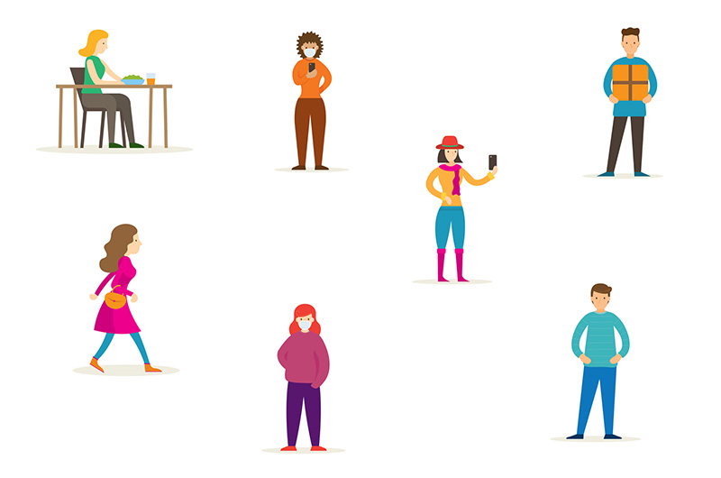

Some people might already be practising keeping this distance if in shops, out for a walk or seeing others in a park. Have you?

**Do not touch other people:**  
When back at school, a new rule will be not to hug or touch other people. Try a big wave to friends or your teacher instead.

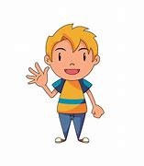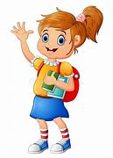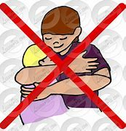

**Washing hands often:**  
Washing hands more often will be a rule. Teachers will remind everyone to wash their hands. It is important to wash our hands with soap and warm water for 20 seconds. Try singing Happy Birthday twice. This takes about 20 seconds.

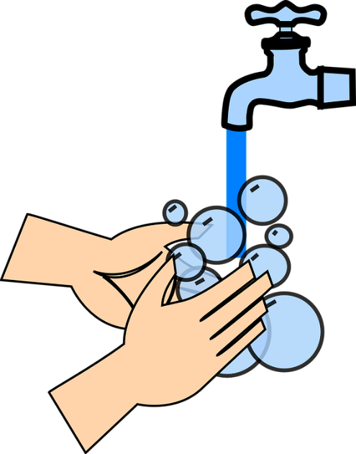

**Good Hygiene**:

Keep tissues nearby. When blowing your nose, do it in a tissue, put the tissue in the bin and wash your hands straight away. Coughs or sneezes should be done into a tissue. The tissue should be put in a bin and hands washed. If there are no tissues available, cough or sneeze into your elbow.

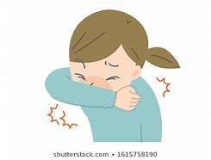

**Feel sick or unwell?**

If you feel sick or unwell at school, tell a teacher or another adult.

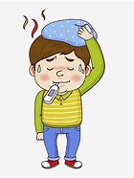If you feel sick or unwell at home, tell your parents or an adult.

When you return to school other things will be different. Here are some examples:

* The length of time in school for the first two weeks will be shorter
* Allocated drop off and collection times
* Enter the classroom via the main front door
* Temperature checks will be completed every morning
* Hands **must** be washed regularly throughout the day
* Each child will have a tray with their work in it
* The layout of the desks
* The time of break and lunch. Other classes will have break and lunch at different times.
* In the playground, each class will have a designated playing area.
* Staff will be wearing a visor or mask

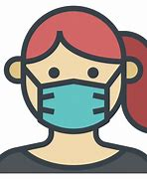

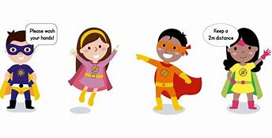

When back at school, some things will be the same…

These things will include:

* Learning
* Our school uniform
* Each class will have a teacher to talk to
* School rules will be talked about
* Literacy, Numeracy, RE, PDMU, World Around Us, PE and The Arts will all be taught
* Playing with friends and having fun

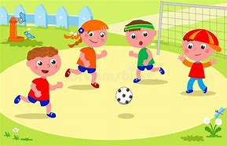

What other things do you think might be different or the same when you go back at school?

Talk about this with someone in your family.

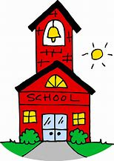

Now that you have worked through your booklet, how do you feel about going back to school?

**How Do I Feel Today?**



School may be different, but it will be good to go back to school.

Think of 3 things you are looking forward to when you are back at school.

What I am looking forward to …



See you all very soon!